**5 - lesson 5 H&S exam (2365)**

Today we had a health and safety test as part of the conclusion of the mandatory health and safety module.

The test consisted of 25 questions. Pass score is 16 out of 25 or higher. This is equivalent to 60%. The pass percentage is very generous.

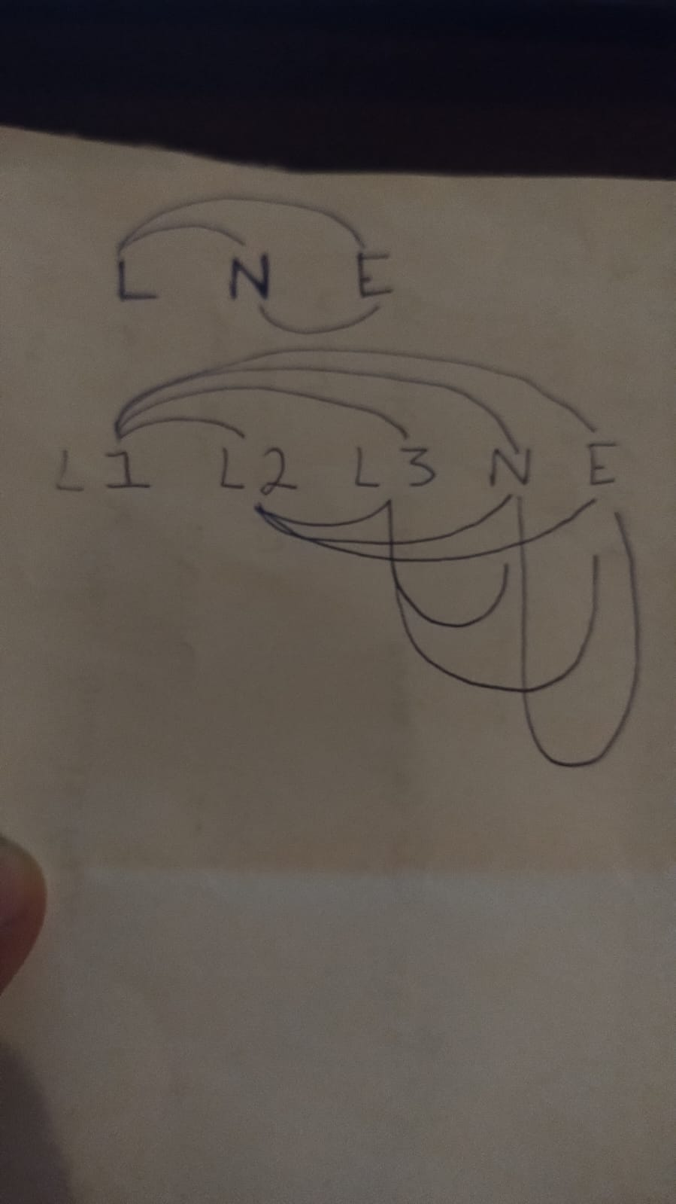

Single phase test

L-N

L-E

N-E

Three phase test

L1 - L2, L2 - L3, L3 - N, N -E,

L1 - L3, L2 - N, L3 - E,

L1 - N, L2 - E,

L1 - E